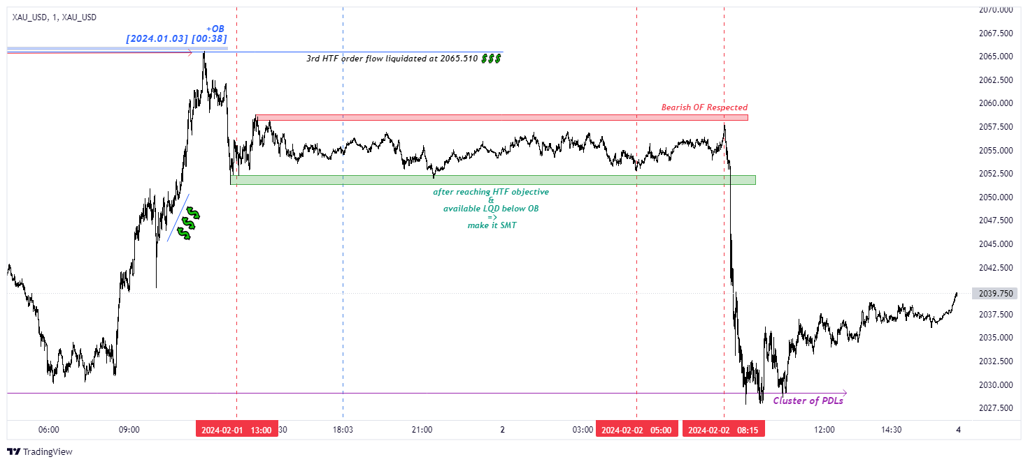

🟡 [https://www.tradingview.com/x/EPZIlEQb/] XAU LTF SMT

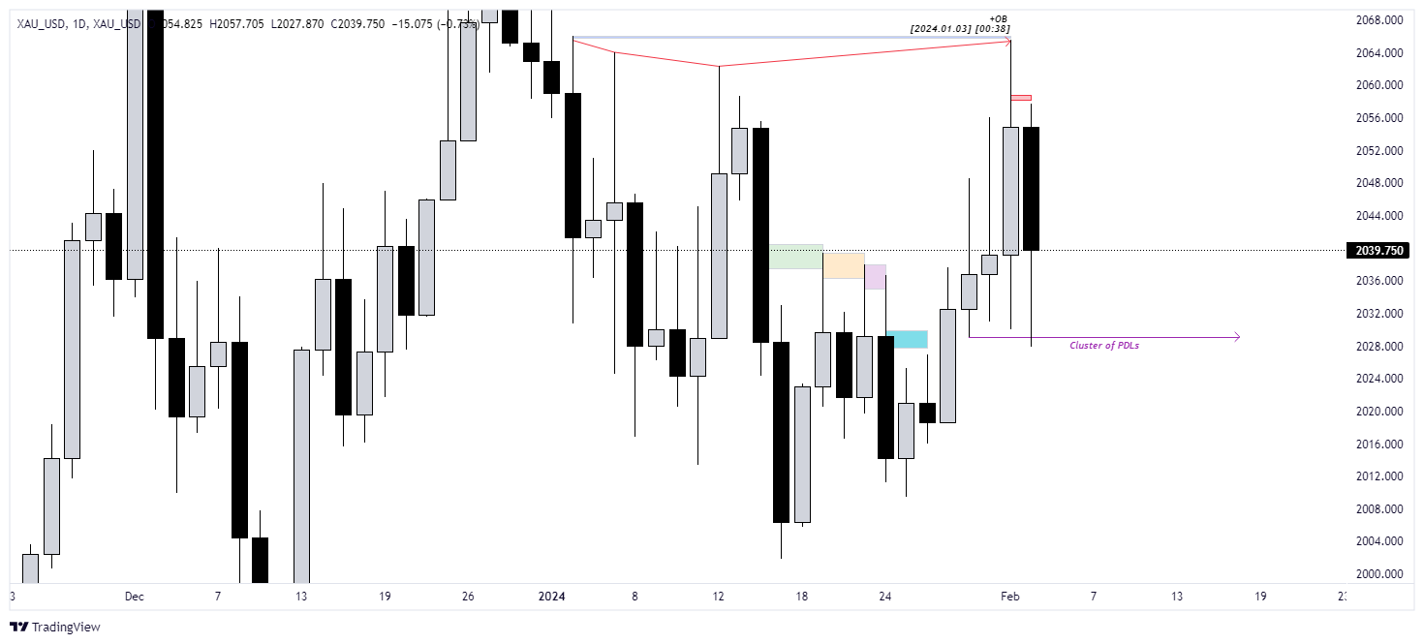

🟡 [https://www.tradingview.com/x/4nHM7Do1/] XAU HTF Cluster of PDLs